Great performance. Better ride.

Sun Life MFS Funds have one focus – to create *long-term* value for investors while actively managing risk.

**Job well done.**

**Series F Performance as at September 30, 2021**

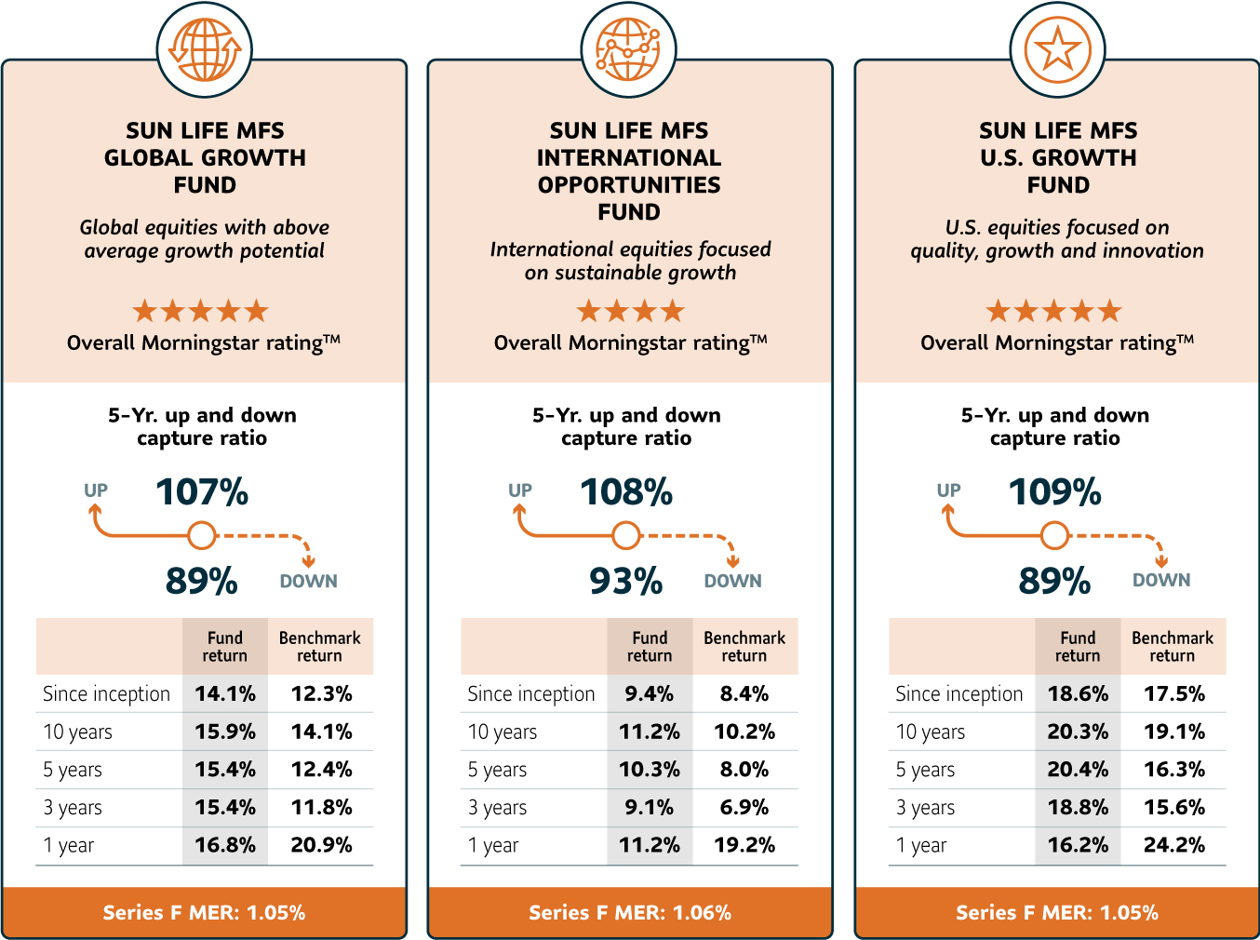

Source: Morningstar Direct. Data as at September 30, 2021. All statistics shown are for Series F. The inception date for the three Sun Life MFS Funds, Series F is October 1, 2010.The fund benchmarks and the calculation benchmarks used for up and downside capture are: Sun Life MFS Global Growth Fund – MSCI All Country World Index C$; Sun Life MFS International Opportunities Fund –.MSCI EAFE Index C$; and Sun Life MFS U.S. Growth Fund – Russell 1000 TR Index C$; Index up and down capture = 100%. MERs are as at September 30, 2021.

**Switch to Sun Life MFS Funds>**

MFS Investment Management or MFS refers to MFS Investment Management Canada Limited and MFS Institutional Advisors, Inc. MFS Investment Management is the sub-advisor to the Sun Life MFS Funds; SLGI Asset Management Inc. is the registered portfolio manager.

The up capture ratio measures investment performance in up-markets. It is compared to an index during periods when that index has risen. A ratio greater than 100 indicates outperformance versus the index during the up market. A ratio less than 100% indicates underperformance. The down capture ratio is similar although it measures performance when that index has dropped.

The corresponding up and down capture ratios and the Morningstar ratings for Series F of the funds for the period ending September 30, 2021 are:

**Sun Life MFS Global Growth Fund, Series F**: Up Capture: 1-year: 97%; 3-years: 107%; 5-years: 107%; 10-years: 105%; since inception (Oct. 1, 2010): 105%; Down Capture: 1-year: 137%; 3-years: 90%; 5-years: 89%; 10-years: 94%; since inception (Oct. 1, 2010): 93%. Morningstar ratings (vs. Global Equity Category): 3-years: 5 stars (vs. 1,796 funds); 5-years: 5 stars (vs. 1,318 funds); 10-years: 5 stars (vs. 582 funds).

**Sun Life MFS International Opportunities Fund, Series F**: Up Capture: 1-year: 78%; 3-years: 103%; 5-years: 108%; 10-years: 98%; since inception (Oct. 1, 2010): 96%; Down Capture: 1-year: 117%; 3-years: 88%; 5-years: 93%; 10-years: 89%; since inception (Oct. 1, 2010): 85%. Morningstar ratings (vs. International Equity Category): 3-years: 4 stars (vs. 593 funds); 5-years: 4 stars (vs. 461 funds); 10-years: 4 stars (vs. 230 funds).

**Sun Life MFS U.S. Growth Fund, Series F:** Up Capture: 1-year: 96%; 3-years: 106%; 5-years: 109%; 10-years: 105%; since inception (Oct. 1, 2010): 104%; Down Capture: 1-year: 160%; 3-years: 93%; 5-years: 89%; 10-years: 102%; since inception (Oct. 1, 2010): 99%. Morningstar ratings (vs. U.S. Equity Category): 3-years: 5 stars (vs. 1,381 funds); 5-years: 5 stars (vs. 1,097 funds); 10-years: 5 stars (vs. 394 funds).

Commissions, trailing commissions, management fees and expenses all may be associated with mutual fund investments. Investors should read the prospectus before investing. The indicated rates of return are the historical annual compounded total returns including changes in security value and reinvestment of all distributions and do not take into account sales, redemption, distribution or other optional charges or income taxes payable by any security holder that would have reduced returns. Mutual funds are not guaranteed, their values change frequently and past performance may not be repeated. Series F is available only to eligible investors who have fee-based accounts with their dealers.

Morningstar is an independent organization that groups investment funds with generally similar investment objectives for comparison purposes and ranks them on a historical basis. Ratings and/or ranking information is subject to change monthly. Other series may have different performance characteristics.

The Morningstar RatingTM for funds, or "star rating", is calculated for managed products (including mutual funds, variable annuity and variable life subaccounts, exchange-traded funds, closed-end funds, and separate accounts) with at least a three-year history. Exchange-traded funds and open-ended mutual funds are considered a single population for comparative purposes. It is calculated based on a Morningstar Risk-Adjusted Return measure that accounts for variation in a managed product's monthly excess performance, placing more emphasis on downward variations and rewarding consistent performance. The top 10% of products in each product category receive 5 stars, the next 22.5% receive 4 stars, the next 35% receive 3 stars, the next 22.5% receive 2 stars, and the bottom 10% receive 1 star. The Overall Morningstar Rating for a managed product is derived from a weighted average of the performance figures associated with its three-, five-, and 10-year (if applicable) Morningstar Rating metrics. The weights are: 100% three-year rating for 36-59 months of total returns, 60% five-year rating/40% three-year rating for 60-119 months of total returns, and 50% 10-year rating/30% five-year rating/20% three-year rating for 120 or more months of total returns. While the 10-year overall star rating formula seems to give the most weight to the 10-year period, the most recent three-year period actually has the greatest impact because it is included in all three rating periods. For greater detail, see **morningstar.ca.**

© 2021 Morningstar Research Inc. All Rights Reserved. The information contained herein: (1) is proprietary to Morningstar and/or its content providers; (2) may not be copied or distributed; and (3) is not warranted to be accurate, complete or timely. Neither Morningstar nor its content providers are responsible for any damages or losses arising from any use of this information. Past performance is no guarantee of future results.

Sun Life Global Investments is a trade name of SLGI Asset Management Inc., Sun Life Assurance Company of Canada and Sun Life Financial Trust Inc. SLGI Asset Management Inc. is the investment manager of the Sun Life Mutual Funds, Sun Life Granite Managed Solutions and Sun Life Private Investment Pools. © SLGI Asset Management Inc. and its licensors, 2021. SLGI Asset Management Inc. and MFS are members of the Sun Life group of companies. All rights reserved.